Geometry: Unit 6, Lesson 4
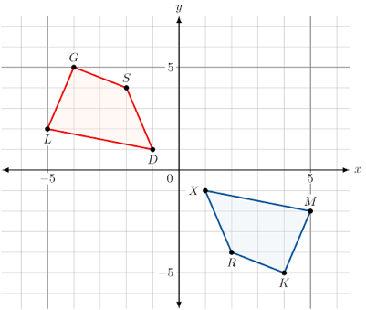
- $KMXR$ is a rotation of $GLDS$ $180°$ clockwise about the origin. What is the algebraic description that represents this transformation?

$$(x, y)→(-x, -y)$$

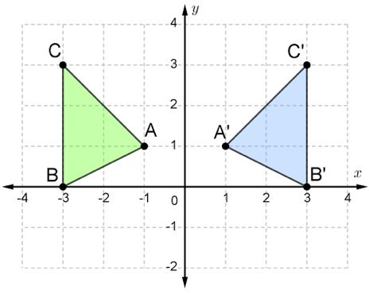
- $∆A'B'C'$ is the result of a transformation of $∆ABC$. What is the transformation that maps $∆ABC$ onto $∆A'B'C'$?

Reflection over the $y$-axis

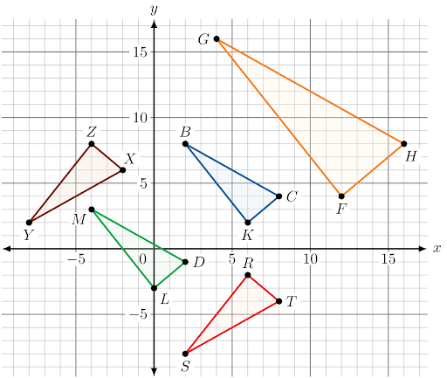
- The diagram shows four different transformations of $∆KBC$. What is $∆RST$ in relation to $∆KBC$?

Reflection across the $x$-axis

